NAME: MUHAMMAD SHARJEEL IQBAL

CLASS: BCS 7B

REG NO: FA20-BCS-022

DATE: 20/9/23

SUBJECT: CC LAB

TEACHER: SYED BILAL BUKHARI

LAB TASK 1:

QUESTION 2:

namespace Lab1Activity2_data_grid_view_

{

public partial class Form1 : Form

{

public Form1()

{

InitializeComponent();

}

// Insert Data

private void button1_Click(object sender, EventArgs e)

{

dataGridView1.ColumnCount = 3;

dataGridView1.Columns[0].Name = "Product ID";

dataGridView1.Columns[1].Name = "Product Name";

dataGridView1.Columns[2].Name = "Product Price";

string[] row = new string[]

{ "1", "Product 1", "1000" };

dataGridView1.Rows.Add(row);

row = new string[] { "2", "Product 2", "2000" };

dataGridView1.Rows.Add(row);

row = new string[] { "3", "Product 3", "3000" };

dataGridView1.Rows.Add(row);

row = new string[] { "4", "Product 4", "4000" };

dataGridView1.Rows.Add(row);

row = new string[] { "5", "Product 5", "5000" };

dataGridView1.Rows.Add(row);

}

// Retrive Data

String value;

private void button2_Click(object sender, EventArgs e)

{

for (int rows = 0; rows < dataGridView1.Rows.Count - 1; rows++)

{

for (int col = 0; col < dataGridView1.Rows[rows].Cells.Count;

col++)

{

value +=

dataGridView1.Rows[rows].Cells[col].Value.ToString();

value += "\t";

}

value += "\n";

}

MessageBox.Show(value);

value = "";

}

// Insert Data in Run Time

private void button3_Click(object sender, EventArgs e)

{

String id = id_textbox.Text;

String name = name_textbox.Text;

String price = price_textbox.Text;

// String[] newRow = new String[3];

// newRow[0] = id;

// newRow[1] = name;

// newRow[2] = price;

// OR

String[] newRow = new String[] {id, name, price };

dataGridView1.Rows.Add(newRow);

}

}

}

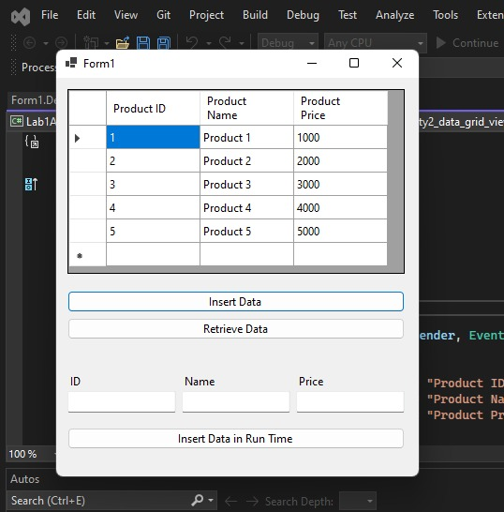

LAB TASK 1:

QUESTION 1:

using System;

using System.Windows.Forms;

namespace calculator

{

public partial class Form1 : Form

{

private double accumulator = 0;

private char lastOperation;

public Form1()

{

InitializeComponent();

}

private void Operator_Pressed(object sender, EventArgs e)

{

// An operator was pressed; perform the last operation

// and store the new operator.

char operation = (sender as Button).Text[0];

if (operation == 'C')

{

accumulator = 0;

}

else

{

double currentValue = double.Parse(Display.Text);

switch (lastOperation)

{

case '+': accumulator += currentValue; break;

case '-': accumulator -= currentValue; break;

case '×': accumulator *= currentValue; break;

case '÷': accumulator /= currentValue; break;

default: accumulator = currentValue; break;

}

}

lastOperation = operation;

Display.Text = operation == '=' ?

accumulator.ToString() : "0";

}

private void Number_Pressed(object sender, EventArgs e)

{

// Add it to the display.

string number = (sender as Button).Text;

Display.Text = Display.Text == "0" ? number :

Display.Text + number;

}

private void Trigonomatric_function(object sender, EventArgs e)

{

string operation = (sender as Button).Text;

double currentValue = double.Parse(Display.Text);

switch (operation.ToString())

{

case "Sin": Display.Text = Math.Sin(currentValue).ToString(); break;

case "Cos": Display.Text = Math.Cos(currentValue).ToString(); break;

case "Tan": Display.Text = Math.Tan(currentValue).ToString(); break;

case "Cot": Display.Text = (1 / Math.Tan(currentValue)).ToString(); break;

case "Sec": Display.Text = (1 / Math.Cos(currentValue)).ToString(); break;

case "Cosec": Display.Text = (1 / Math.Sin(currentValue)).ToString(); break;

